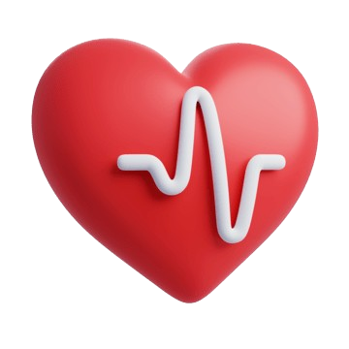
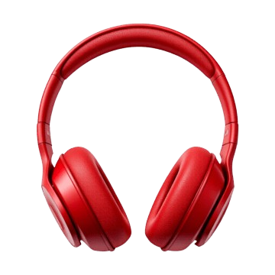
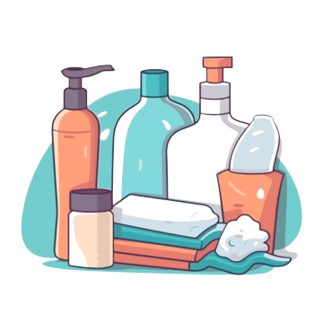
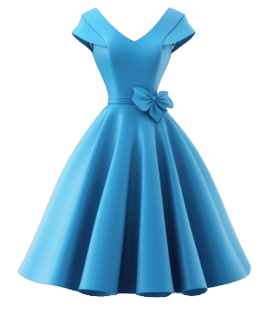
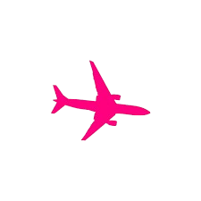
- Aspirin
- Vitamins
- Hand sanitizer
- First aid kit
- Phone
- Chargers
- iPad/laptop
- Headphones
- Watch
- Powerbank
Health
Electronics
Hygiene
Clothes
- T-shirts, tops
- Jeans, shorts
- Pyjamas
- Hoodie
- Shoes
- Jewellery
- Body wash
- Face wash
- Toothbrush
- Shampoo
- Conditioner
- Deodorant
- Skincare
- Perfume
- Lotion
- Hair brush
- Hairties
TRAVEL PACKLIST

